Creating a Custom Excel Conversion

Validate the Source

This section presents best practices for gathering client claim data that will allow for optimal use of Origami’s powerful analytics.

Required and Desired Claim Data
For your conversions/data load to complete successfully, the following data must be provided:
- unique claim number (this can be a combination of fields to create a unique claim number)
- loss date
- report date
- coverage
- status (note we are looking for one character – O, R or C – you will need to adjust either via a formula or manipulation of the spreadsheet)

Ideally the following fields will also be included:
- close date
- reopen date
- financials broken out by ‘bucket’
- Claimant Name
- Loss Description

Your analytics will work best when the following coded fields are provided:
- cause
- state
- body part
- injury
- gender
- Return to Work Date (for WC claims)
- Lawsuit Filed (Y/N field)
- Type of Claim

Best practices
- Ideally you will be able to collect multiple valuations of a claim source, so that you can complete trending analysis.
- Try to get codes rather than description to load in the data to Origami (we’ll have code/descriptions set up in our library).
- When pulling down data from your TPA or Carrier system, use the same standard naming conventions to capture – Carrier_Client_NameofReport_valuation. (e.g. SEDG_Moriarty_LossRun_20120301

Initial analytic work

Once you have confirmed the above fields are in place, you will need to do some initial analytic work to guide Origami on interpretation of data. In Excel, Choose Insert Pivot table for your claim data.

Financial check

If you have Subrogation or Recovery financials, note if these are negative or positive. Origami subtracts these financials out, so if these values are negative on the spreadsheet, you will need to build a formula that makes them positive.

You may not be able to discern from the data provided on your report if your financials are already net of recoveries. Your best bet is to confirm with the source how the financials are generated. If they are net, you will need to add Recoveries back into the financials.

On your pivot table, place your paid values for all financial categories as Sum in the Values Section, along with your total Paid. Confirm that your financial buckets add up to the total Paid (with the notation of subro/recoveries above).

On your Pivot table, set your row label to the status field, place your incurred values for all financial categories as Sum in the Values Section, along with your total Incurred. This will validate if your incurred is your reserves/outstanding or your true incurred (paid plus outstanding).

Check to see if the financials are broken out by bucket (Medical, Indemnity, Expense, etc.). This is crucial to proper reporting. If you cannot get the financials broken out, map what you have to the Unclassified/Other bucket (Paid5, Reserve5).

Data Check
Determining the length of a field – If this is a new source, Origami will look at the first row of data to estimate the appropriate length of a text field. At the end of each text field add a formula to determine the maximum length of that field (e.g., Max(LEN(A2:A45)). If that length is longer than Origami’s estimate, you will need to adjust

On your Pivot table, set your row label to the status field. Origami is looking for O, C or R for status (for Open, Closed, Reopened). If you have ANY other value than that (such as I for Incident, or N for Notice Only, or your R really means Report Only), you will need to build out a formula for status.

Code Mappings - You can use your pivot table to help with mapping of coded fields (body part, cause,etc.), by placing that field in the row label.

Check your field headers. For creating your source:
- the header must be the first row of the spreadsheet.
- Check your headers for duplicate names.
  - Duplicates will only be loaded once. You will need to either remove the duplicate column or change the header name.
- Check to make sure there are no carriage returns or commas in your header row. Carriage returns and commas will prevent the source from being created.
- The data must be in the first worksheet as well.

Create the New Claim Excel Source
For initial creation, this is essentially a wizard that steps through creating the main record, the conversion table, the default mappings, the critical options/financials, and the conversion source method. The initial setup for a new data source should be done at the account level, with client specific field mappings and code mappings configured at the client level. The top right portion of the UI will indicate which level you are operating at currently.
Fundamentally speaking, think of a data source as general configuration, whereas the data update is an actual instance of that data source that uses the data source config as a basis for the update process. You can have multiple instances per data source, which is why we configure the source at the account level so it can be used across multiple clients. But some clients use fields differently, or have different sets of codes that they leverage, which is why the client level mappings overwrite the account level config. The account level setup should be what's consistent across all clients leveraging that data source, the client level setup is specific to them. (this note is repeated at the start of the data update portion)

To create a new Excel source in Origami

- Log in to Origami (select your client if this is a client specific source or you can make this a new global source by not selecting a client)
- Go to Administrator
- Click on Data Sources then choose More/New Excel Source 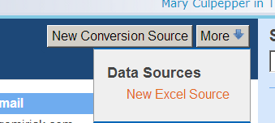

- From here, choose the name of your source, then choose the file from your computer (make sure that the file is not password protected). Please know that the file MUST be in the first tab of the spreadsheet AND the header labels must be in the first row. There can be no carriage returns or commas in the headers as well.

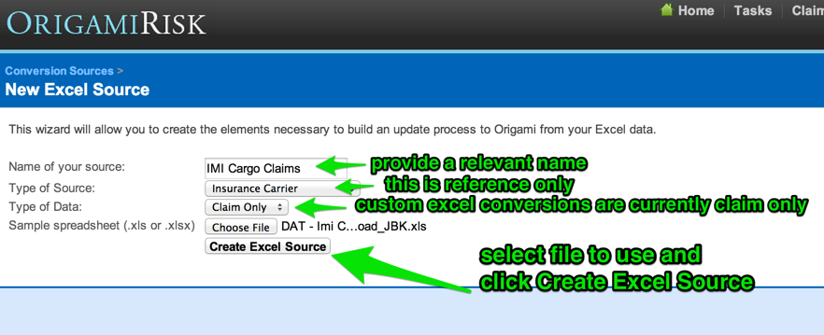

Once the Create Excel Source button is clicked, Origami will read the labels and attempt to define the field, its size and its mapping.

- Adjust field type, size and mapping, then hit save
  - Financial Fields (your reserves/paids/outstandings/incurreds) must be Decimal
  - If you collect Recovery dollars, you will need to confirm that the incurred and paid are gross of Recovery. If they are net of recovery, you’ll need to add those recovery dollars back in.
  - The initial size of a text field is driven by the first row of data in your spreadsheet. Note that coded fields cannot exceed 50 characters in length

You can always come back and edit this section to adjust the size of a field. You can also come back and add a field.

WARNING – Origami does not have any duplication checks on the name of your conversion source. Therefore you should confirm that your Excel Source name is unique prior to hitting save, otherwise Origami could overwrite an existing source.

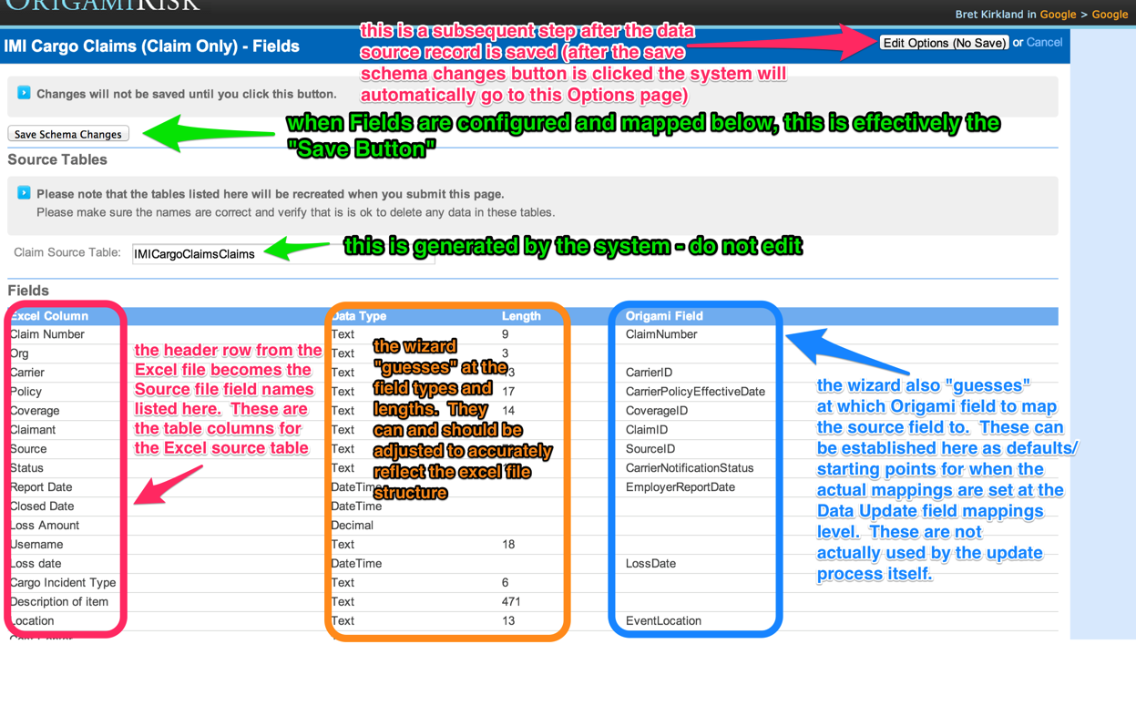
Field mapping setup done at this stage should be applicable to other clients, client-specific configuration can be done at a later step.
-You can't modify the leftmost column, the labels are taken directly from the first row of the excel spreadsheet, so that would be where you correct them if needed, then you'd have to start a new source with the different layout that has the correct column headings. Alternatively, you could add a new field with the proper label and remove the mapping on the old field so it's not in use.
-The order of the column headers does not have an impact on the update. The config on the field mappings essentially makes the order irrelevant, as well as having additional columns in the upload won't impact anything as long as you don't have them mapped to an Origami field. The system looks for the column header, leverages that to know what field it's working with, and handles the data according to any of that configuration; only mapped fields will get pulled into the update.
After clicking the Save Schema Changes button, Origami will open the following screen for configuration of the “critical fields and options”. This can also be accessed/edited later by accessing per the following path: Admin - Data Sources - Select Data Source Name - “Edit Excel Template” button - “Edit Options (No Save)” button.

- Map Critical Fields/Build out Formulas. The next screen is further mapping for required fields, where you can build out formulas for fields and set up some exception handling steps.

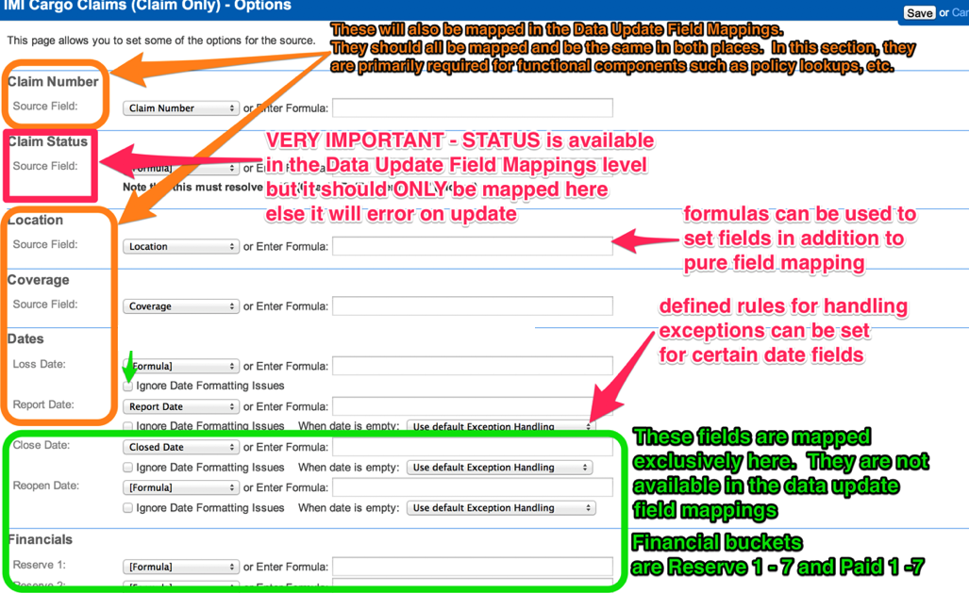

Writing formulas can be a challenge, here are a few examples here:

Status: (DT_STR,1,1252)({Status} == "Closed" ? "C" : "O")
-This example reads the value coming in from the source {Status} field, if the value is “Closed” then it returns a value of C, else it returns O. The (DT_STR,1,1252) defines the data type(DT) as string (STR), with a character length of 1. The 1252 is a standard that must be included with string fields.

Date Reported: (DT_DBDATE)(!ISNULL(DateReported) ? DateReported : !ISNULL(DateOpened) ? DateOpened : DateOfLoss)
-This example checks if the value of DateReported is not null/empty (!ISNULL), if it is not null then it populates the origami date reported field with the source date reported field, else if date opened is not null then date reported is populated with date opened, else use DateOfLoss.

Occurrence Number: (DT_STR,25,1252)(ISNULL({OccurrenceNumber})?{ClaimNumber}:{OccurrenceNumber})
-If the incoming OccurrenceNumber field is null, then populate OccurrenceNumber with ClaimNumber, else use OccurrenceNumber.

IMPORTANT NOTE: BEWARE OF FINANCIAL ROUNDING ISSUES

When setting up the financials for a custom Excel template, beware combining multiple fields together like this:
(DT_DECIMAL,18)({Paid} + {Reserve})
This will result in unexpected rounding. The way to overcome this is to separate the fields:
(DT_DECIMAL,18){Paid} + (DT_DECIMAL,18){Reserve}
Similarly, recoveries will be rounded if you multiply by -1:
(DT_DECIMAL,18){Recovery} * -1
To overcome this, add decimals to the constant:
(DT_DECIMAL,18){Recovery} * -1.00

For Financials, remember our financial buckets are
1 - Medical
2 - Expense
3 - Indemnity
4 – Legal
5 – Unclassified/Other
6 – Recovery – We store recoveries as a positive number. Incurred formulas determine if the number should be ignored or subtracted. If your report provides Recovery as a negative, you will need to create a formula like this one: (DT_DECIMAL,18)(-1.00*({SubroRec})
7 – Subrogation – This is also stored as a positive number.

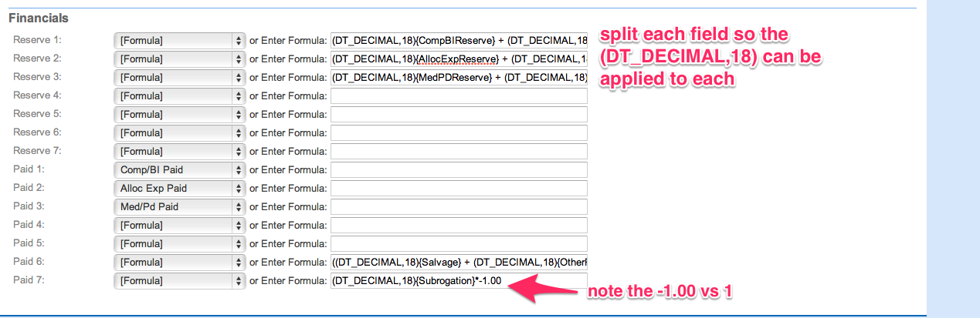

Conversion Source Method
Once the critical options are saved, Origami displays the conversion source method page which corresponds to the newly created data conversion source. This can also be accessed/edited later by accessing per the following path: Admin - Data Sources - Select Data Source Name - Select Conversion Source Method hyperlink. There can be multiple conversion methods for each conversion source although this would be rare and is primarily used by companies with multiple clients where each client may have a unique data conversion method. Many conversion source method settings will already be established from prior steps in the conversion source creation so little will need to be changed.

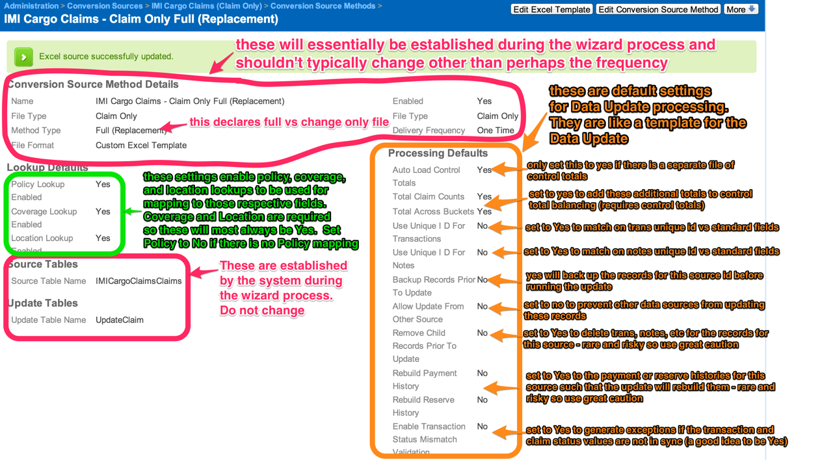

-For the most part these settings can be left as the default, in most cases during setup it is a good idea to turn Auto Load Control Totals to ‘Off’ unless you have a separate control totals file. If you’ve imported claim data outside your source and those claims should be updated by the source you are creating, set the “Allow Updates from Other Source” to Yes. The update typically only looks at claims that have been created by the source as the universe of claims to update.
Create the Data Update Process
Fundamentally speaking, think of a data source as general configuration, whereas the data update is an actual instance of that data source that uses the data source config as a basis for the update process. You can have multiple instances per data source, which is why we configure the source at the account level so it can be used across multiple clients. But some clients use fields differently, or have different sets of codes that they leverage, which is why the client level mappings overwrite the account level config. The account level setup should be what's consistent across all clients leveraging that data source, the client level setup is specific to them. (this note is repeated at the start of the data source portion)
- The following is done at the Client level
- Log in to Origami and select your client
- Go to Administrator
- Click on Data Updates, then choose New Update Process. In Origami, your Excel sources all have EXCEL in their source name.
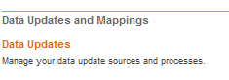

- Select the source
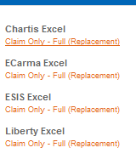

- Adjust the Frequency, otherwise Click on Save Changes
(in cases where the document will be loaded manually, the frequency option is not as impactful. This option is mainly leveraged for data feeds)
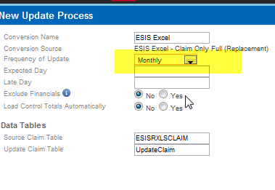
- Validate/Update Date Field Mappings. Go to field mappings to confirm the mappings from the account level were inherited to the client level. At this point you will need to update the code lists for any coded fields(alternatively some prefer to take care of this during the exceptions handling stage), which can be done by clicking on the ‘Code Mappings’ option on field in the Field Mappings Section. Additionally it’s a good idea to verify the field mappings are mapped how you would expect them to be based on the config at the account level. Any additional client-specific fields should be mapped at this stage, as well as any differences in mappings from the account level.
  - Don’t forget on your coded fields to check your code mappings.
  - While most of your field mappings should be global (i.e. configured at the account level), code mappings need to be configured at the client level.
  - Field Mappings can also be accessed by opening the Data Update record and selecting Field Mappings from the More Menu.
  - client level mappings will overwrite account level setup. Meaning if you mapped Location to LocationID on your data source at the client level, when you then start a new update process at the client level, it will inherit that Location to LocationID mapping. However, if you enter the field mappings section at the client level then any further configuration will overwrite that

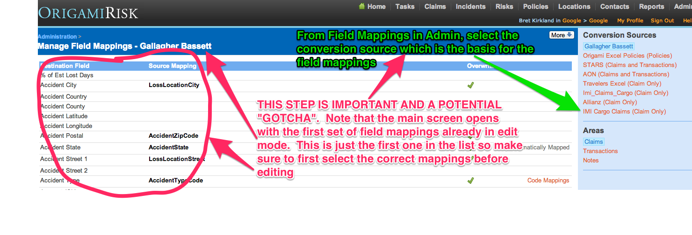

Run the Update (aka Start the Update)

Initiate the Update
- If you’re not already there, log in to Origami and select your client
- Go to Administrator
- Click on Data Updates, Select your data source (it should already be listed) and Start this update

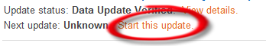
- Highlighted below are the key fields: You’ll need to populate valuation date as well as choose source file option of ‘Upload file using info below’
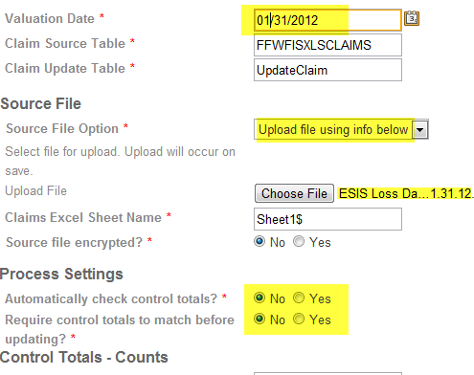

- Once these fields are selected, Choose Start Update process
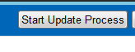

Origami will ask you to verify the data following Step 2 – Convert the data. 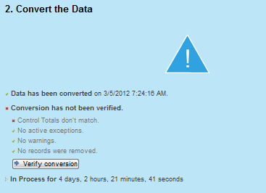
You may have exceptions that will need to be addressed prior to verification. Presuming all goes well, once verified, your update will move into Update Production Data

A successful completion looks like this
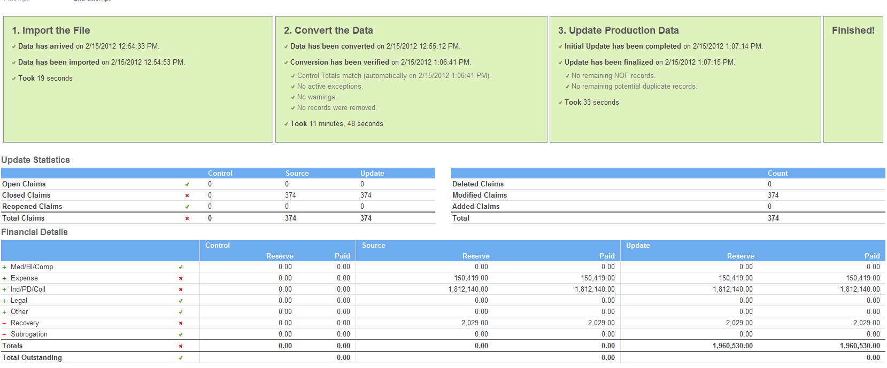

Exception Handling

If there are some issues with the data, you’ll see a reference in Step 2 about exceptions.

NOTE: since code mappings in the exception management UI can be saved permanently, many users don’t even attempt to map codes before the update and simply let them all manifest as exceptions - this effectively utilizes the exception navigator as the code mapping tool for the update.

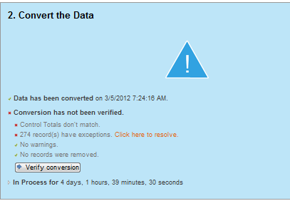

To resolve exceptions, you would select ‘click here to resolve’

For each type of exception, Origami will provide choices for how to resolve the issue. Most likely, you will need to define a new mapping (see example below)

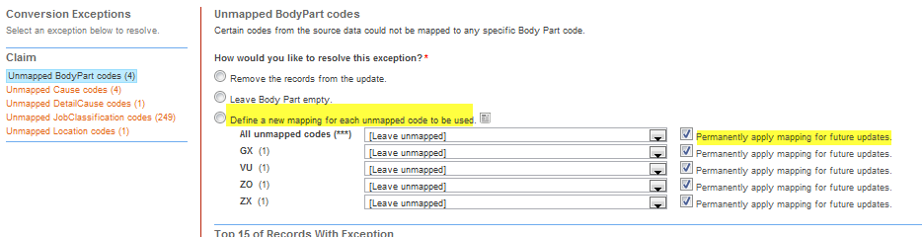

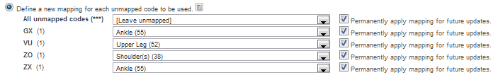

Once you have established the new mapping, choose resolve exception
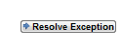
** Should you run into additional errors within this 3 step update process or are concerned about handling exceptions yourself, please reach out to your Origami consultant for assistance.

Exception Defaults are accessed by opening the Data Update record and selecting Exception Defaults from the More Menu:

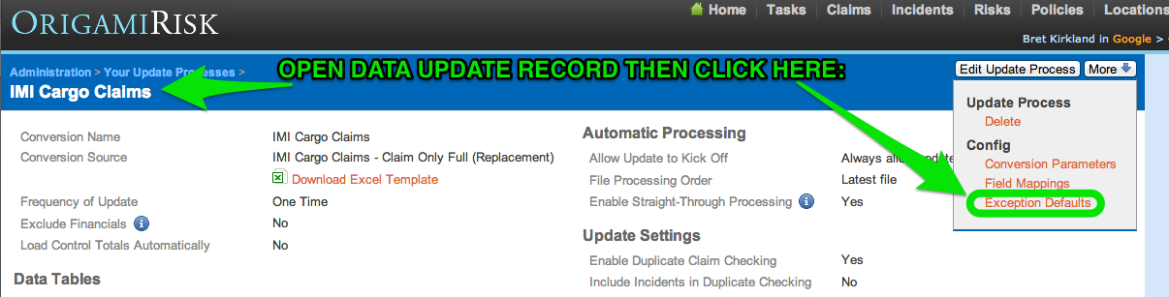

If nothing is established here, exceptions will just be generated during the update process (generating an exception is the “default exception handling”). This is used to pre-determine potential exceptions and automate their resolution up front.
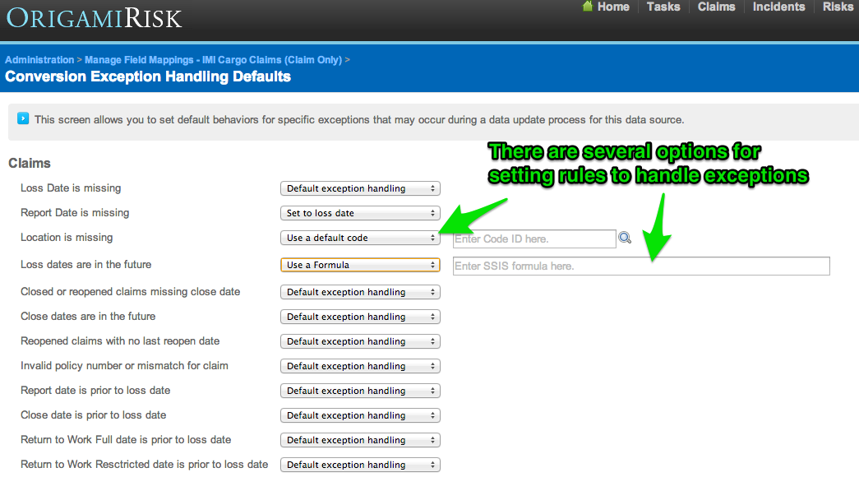

Error Resolution
Errors in the update process can be difficult to troubleshoot. Below is a list of errors and steps you can take to attempt to resolve.

Errors on File Import Step:

Error Description: Error occurred executing file import command ImportFile: There were no mapped columns found for domain Claim.
Possible Resolution: Confirm that the starting row that is specified in the conversion matches the starting row of the raw file. In particular, look for special characters such as carriage returns and commas.

Error Description: The package execution process failed due to the following errors. Error Code: -1073450901 Description: "component "<Source Table> failed validation and returned validation status "VS_NEEDSNEWMETADATA".
Possible Resolution: Check to see if your header rows changed from the previous successful update with this source. If a header name changes, this error will appear. If a header has changed, confirm what the field name will be going forward with the source. A new field may need to be added to the source.

Error Description: Column index can't be lager than maximum column index (16383). Parameter name: index Actual value was 16384
Possible Resolution: Make sure your source data does not contain any of the following:
- Formulas
- VLOOKUPs
- Formatting such as table header rows (not to be confused with column header rows). You can fix this by selecting the entire worksheet, then going to Home --> Editing --> Clear --> Clear Formatting.
- Frozen panes. You can fix this by going to View --> Freeze Panes --> Unfreeze.

Try removing all of these from the spreadsheet. If all else fails, try to copy the results of the spreadsheet to another blank spreadsheet, update the cell range, and try the update again using the new spreadsheet.

Errors on Conversion Step:

Error Description: "Could not find destination column <COLUMN_NAME> to map to destination table. "
Possible Resolution: You have a field in your mappings that was not included in your source file. Either remove that mapping in the Field Mappings section, or add that field back into the source file.

Error Description: SSIS Error Code DTS_E_PROCESSINPUTFAILED. The ProcessInput method on component "Pivot on Status" (17359) failed with error code 0xC0202090 while processing input "Pivot Default Input" (17360).
Possible Resolution: The key words here are Pivot on Status. Check your status fields in your source. Are there new records that haven’t yet been accounted for? Do you have a formula for Status? Check to make sure all records resolve to O,C, or R.

Errors on Update Step

Error Description: Cannot insert duplicate key row in object 'dbo.Claims' with unique index 'UIDX_Claim_ClaimNumber'. The duplicate key value is (xxxxx, xxxxx).
Possible Resolution: The issue here is that your update is set to NOT allow updates on claims entered from other sources. If you’ve loaded claims another way other than this source, you will want to modify your Update Process record. In admin, go to Data Updates. Click on your update process name. Click Edit Update Process and switch the “Allow Update of Records from Other Sources” to Yes. Go back and re-start your step.

